Application Packet
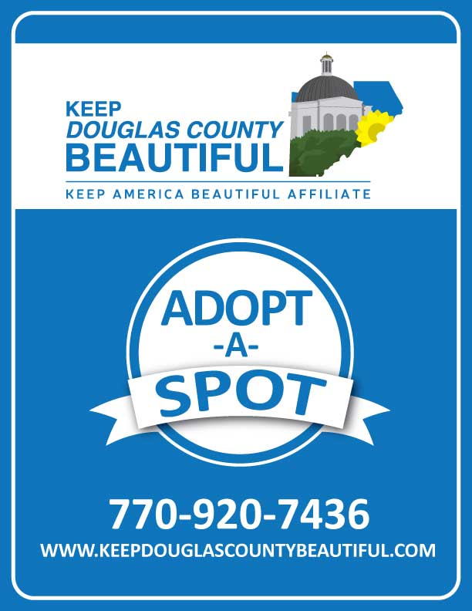
Application Packet
ADOPT-A-SPOT

Annual Program Agreement
Sponsored by:

Keep Douglas County Beautiful

AND
Douglas County
DEPARTMENT OF TRANSPORTATION

Contact: Keep Douglas County Beautiful
Director: Tiffany Stewart-Stanley
Phone: 770-920-7436
Email: tstewartstanley@co.douglas.ga.us
Fax: 770-920-7357
Coordinator: Tabrieah Cobb
Phone: 770-920-7593
Email: tabrieahcobb@co.douglas.ga.us
Fax: 770-920-7357
DOT Director: Miguel Valentin
Phone: 770-920-4924
Email: mvalentin@co.douglas.ga.us
Fax: 770 920 4933

The Adopt-a-Spot litter prevention initiative, sponsored by Douglas County Department of Transportation (DOT) and Keep Douglas County Beautiful (K.D.C.B), enables citizens to actively participate in the removal of trash and illegal signage alongside county right-of-ways.

The right-of-way is defined as the space between utility poles and the curb of the road. Illegal signs are defined as any sign that is mounted on any utility pole or any temporary sign within 10 feet of the curb or edge of pavement in the right-of-way.

GETTING STARTED

- Get a group together and plan to complete a minimum of 4 cleanups per year.
- Work with K.D.C.B to determine an appropriate road section: at least 1-mile in length and where there is a litter problem that you can help with.
- Fill-out and send in the Adopt-a-Spot Agreement to K.D.C.B.
- Contact K.D.C.B to request supplies to loan at least a 5 business days before your first cleanup (include about how many people you will need supplies for).
- Have each member of your group sign a copy of the attached Volunteer Waiver.
- Supplies provided by K.D.C.B and DOT include safety vests, trash bags, grabbers, and gloves.
- Return checked-out supplies within 2 business days after your cleanup.
- Submit your Post-Cleanup Report within 30 days to K.D.C.B!
- Two Road Signs with your name will be installed after K.D.C.B receives your second Post-Cleanup Report.

VOLUNTEER RESPONSIBILITIES
- Select an Authorized Representative to officiate as the group's spokesperson.
- Receive approval from K.D.C.B for the road section you want to adopt. Road section must be at least 1 mile in length. State Routes are not eligible under this program. Use cross-streets or intersections to describe the “To” and “From” lengths rather than landmarks or exact addresses.
- Sign and return the “Adopt-a-Road” Agreement form to Keep Douglas County Beautiful. This must be updated each year at the time of its expiration.
- You must complete and report a minimum of 4 cleanups per year. If you are a new group, this will be determined based on your start date. After the first year, this will be determined by the annual year.
- Submit the “Schedule of Cleanups” form to K.D.C.B. This is for your planning purposes, and you can change the dates as needed.
- Have all program participants sign a Volunteer Waiver and return to K.D.C.B.
- Notify K.D.C.B at least 5 business days before your cleanup event and request supplies (if needed) by the group (vests, bags, and grabbers).
- Remove litter, debris, or trash within the right-of-way of the adopted road section.
- Remove signs, posters or other display material within the adopted road section that could distract motorists.
- If you have too much trash or there are materials too large for you to remove, you can request a “DOT Pickup” on the Post-Cleanup Report. To request a pick-up, you must gather all materials at one pick-up location that is:
  - In a clearly visible location within the right-of-way.
  - Near an intersection that you can provide for direction in the Post-Cleanup Report.
- File a Post Cleanup Report after each cleanup within 30 days to K.D.C.B.
- Update Volunteer Waivers as participants change and submit forms to K.D.C.B.
- If a group loses or damages any supplies that were loaned out through K.D.C.B, the group must reimburse K.D.C.B for the materials according to the market price for those supplies.
SAFETY GUIDELINES
- Watch out for traffic.
- All program participants are required to wear safety vests during pickup. Those individuals that do not wear safety vests must not be allowed to participate in the work group.
- Clothing worn should not impair either vision or movement during cleanup, nor should it distract motorists that may be driving past the work group.
- Adequate supervision must be provided by one or more adults 21 years of age or older for groups which have participants 12 to 17 years of age (IMPORTANT: No one under the age of twelve (12) is allowed to participate in these groups).
- Participants shall not possess or consume alcoholic beverages or other drugs during cleanup activities.
- Work groups should be kept to a manageable size.
- Participants should alert their co-workers and Authorized Representative of any known allergies they have before they are allowed to work. Contact with poisonous plants, venomous snakes, and stinging insects is possible.
- Hazardous material or debris should not be removed but should be reported to K.D.C.B.
- Construction areas should be avoided.
- Dead animals should not be handled. Report these to Animal Control for removal by calling 770.942.5961.
- Debris and litter on bridges, overpasses, or in tunnels should not be picked up.
- The group should not remove litter during inclement weather, hours of minimal light or in darkness, and times of day in which peak traffic occurs.
- Personal vehicles should be parked clear of the roadway.
- To keep vehicles to a minimum, carpooling to the cleanup area is recommended.
- Water and First Aid items should be readily available for participants.

SERVICES PROVIDED BY PROGRAM SPONSORS
Keep Douglas County Beautiful
- Work with the group to determine the specific section of road to be adopted.
- Furnish safety vests, latex gloves, safety signs (if desired), trash bags, and litter pickers (first come, first serve) for the cleanup day. Groups must return the signs and safety vests within 3 days after the cleanup.
- Coordinate removal of trash bags.
- Monitor work progress to verify that objectives of program are being met regarding litter abatement.
- Terminate affiliation with those groups that fail to perform in a congruous manner with program rules and regulations.
DOUGLAS COUNTY DEPTARTMENT OF TRANSPORTATION
- Erect two signs, one at each end of the adopted road, with the group’s name or acronym displayed after completion of the second post clean-up report.
- Remove litter, debris, or trash from the adopted section of roadway that is too large, heavy, or hazardous for the group to remove.
- Take down signs of groups who have terminated their involvement in the program.

PROGRAM LIMITATIONS
- Administrative, legislative, financial, and/or legal constraints may subject the Adopt-A-Spot Program to certain limitations.
- The sponsoring organizations shall determine which county roads are appropriate for adoption. State highways are not eligible for the Adopt-a-Spot Program.
- No interstate highway pickups will be allowed and no holiday pickups will be scheduled without prior approval.
- The program will not permit any political activity that may arise from participating groups during activities related to cleanup. This policy is consistent with laws prohibiting expenditure of public funds, either directly or indirectly, for influencing elections for the outcome of any legislation. The sponsors will have the right to take all measures necessary including, but not limited to, the removal of erected signs displaying participants’ names determined to conflict with statutory restrictions or any restrictions on the use of public funds for political activity.
- Commercial organizations cannot display any product, service, person’s name, product I.D., address, phone numbers, logos, or web address on erected signs with the organization’s name.

ACCEPTANCE INTO THE ADOPT-A-SPOT PROGRAM
- The adoption of a section of roadway is franchised by the sponsors to qualified groups who agree to assist the Adopt-a-Spot Program in achieving its purpose and goals. Only those individuals and/or groups that are deemed responsible will be qualified to adopt a spot. Individuals and/or groups that have demonstrated violent and/or criminal behavior shall be prohibited from adopting a section of roadway.
- The sponsors may refuse to grant a request to adopt a section of roadway if, in its judgment, granting said request would jeopardize the program, be detrimental to its purpose, or create a safety hazard to the traveling public. Safety is a principal concern in all decisions related to the program.
- Program participants must agree to not hold the sponsors responsible for injuries that they may suffer or damages that they may cause or incur as a result of participation in the program.

STATUS AND RECOGNITION

As participating groups continue to be involved, the group earns one of four statuses in the program, depending on the level of involvement:
- Excellent: for participating groups that have reported more than the 4 required annual cleanups for the last 2 years. These groups will receive an annual Certificate of Excellence with their group name listed on the Keep Douglas County Beautiful website to recognize their efforts.
- Good: for participating groups that have reported the required 4 cleanups for at least 2 years, or one year for new groups. These groups will receive an annual Certificate of Recognition with their group name listed on the Keep Douglas County Beautifulwebsite to recognize their efforts.
- Probation: for participating groups that have failed to report the required 4 cleanups, resulting 6 cleanups or less for two annual years. These groups will be notified of their probationary status and be given one year upon the renewal of their Agreement to complete the required 4 cleanups. Should the group fail to complete the minimum requirements for the program during the probationary year, at the end of this time period the group will be required to relinquish the adopted road. Relinquished roads cannot be re-adopted for a period of one year. If another group adopts the road during this time, the group will have to adopt a different road upon re-entering the program.
- Disengaged: for participating groups that have reported zero cleanups over the span of two annual years. These groups will be notified that their adopted road is relinquished for at least one full year. They will be allowed to re-enter the program, should they desire, once a full year has passed from the time of termination. If another group adopts the road during this time, the group will have to adopt a different road upon re-entering the program. Groups who were disengaged previously will not be permitted to re-enter the program a second time.

MODIFICATION/ RENEWAL/ TERMINATION AGREEMENT
- The Adopt-a-Spot agreement may be modified in scope or altered in any manner at the discretion of the sponsors.
- The participating group will have the option of renewing the agreement, subject to review and approval by the sponsors. At the time of renewal, the informational database concerning the group will be updated.
- The sponsors may terminate the agreement and/or remove Adopt-a-Spot signs bearing the program participant’s name or acronym if it is determined that the group is not meeting the terms and conditions of the agreement, acting contrary to the guidelines of the program, engaging in irresponsible conduct at adopted work sites, proving to be counterproductive to the program’s purpose, or increasing litter, vandalism, or sign theft have occurred since adoption. The group’s Authorized Representative may appeal termination of the agreement with the sponsors.
Adopt-A-Spot Program Application

- I want to adopt a spot in Douglas County

- I would like to renew my current adopted location

First Name: _________________________ Last Name: ______________________
Home Phone: ________________________ Cell Phone: _____________________

Email: __________________________________________________________________________

Group Affiliation, if any: __________________________________________________________________________

If you are a member of a group, are you the group’s spokesperson? ___ Yes ___ No

I would like to adopt/renew the following location(s) if available:

Date: ____________________
Registration Form
Group Name:
Primary Contact Name:
Phone:
Email:
Mailing Address:

Secondary Contact Name:
Phone:
Email:
Spot Request:
Approximate Number of Participates:
Name to be placed on the sign:

___________________________________ __________________________________
Authorized Group Representative Name Authorized Group Representative Signature
Date: _____________________________
Schedule of Cleanups

Please submit dates for your cleanups

Group: ____________________________________________________________________
Contact: ___________________________________________________________________
Phone Number: ____________________________
First cleanup date: __________________________________
Second cleanup date: ________________________________
Third cleanup date: __________________________________
Fourth cleanup date: _________________________________
Optional cleanup date: _______________________________

Adopt-A-Spot
Terms and Conditions
________________________, agree to adopt ________________ spot for the duration of two years starting date: _______. By adopting this spot, I agree to pick up litter a minimum of once per quarter (four times a year).
Conditions:
- The participant(s) shall develop and follow a regular schedule of litter removal as agreed upon by Keep Doulas County Beautiful
- Keep Douglas County Beautiful will provide the paperwork and equipment required to perform tasks under the Adopt-A-Spot program. Borrowed and unused supplies must be returned to the Keep Douglas County Beautiful office located on the third floor of the Douglas County Courthouse.
- The Volunteer leader shall keep track of and report all volunteers and volunteer hours to Keep Douglas County Beautiful. A volunteer sign-in sheet will be provided.
- Keep Douglas County Beautiful may photograph or videotape the events or activity for the purpose of promoting Keep Douglas County Beautiful and its services and community programs.
- Participants under the age of 18 must have adult supervision and must have a signed parental release form.
Volunteer Leader Signature: _____________________________ Date: _________

Parental Release Form
______________________, who is under the age of eighteen, has my permission to participate in the Keep Douglas County Beautiful Adopt-A-Spot program.
I hereby give permission to Keep Douglas County Beautiful to use any photographs or videos taken by Keep Douglas County Beautiful staff or board members of my minor during participation in this program.
__________________________________
Printed Name
__________________________________
Parent or Legal Guardian Signature
__________________________________
Date

Litter Kit Rental Application

Event Date(s) _____________________________________________________
Event Name ______________________________________________________
Event Location ____________________________________________________
Name of Borrower __________________________________________________________________
Borrower’s Organization __________________________________________________________________
Borrower’s Address __________________________________________________________________
City __________________________________ State ___________ Zip ______
Borrower’s E-mail _________________________________________________________________
Borrower’s Phone Number __________________________________________________________________
Brief Description of Event __________________________________________________________________
__________________________________________________________________________
Email: tabrieahcobb@co.douglas.ga.us, Mon.-Fri. between the hours of
8:30 am and 4:30 pm. to schedule a Litter Kit pick up.
Borrower’s Signature __________________________________________________________________
Date : _______________

Post Cleanup Form
Please submit within 30 days after each cleanup to:
Fax: 770-920-7357
Email: tabrieahcobb@co.douglas.ga.us
(subject MUST BE titled: post-cleanup-form)
Mail: 8700 Hospital Drive Douglasville, GA. 30134

CONTACT INFORMATION
Group Name: _________________________________________________________
Contact name: __________________________ Phone: (_____)________________
Email address: ________________________________________
CLEANUP DETAILS
Date of Cleanup: _______________ Location of Cleanup: _______________________
# of bags of garbage you collected: _______ # of illegal signs you collected: ________
Approximate weight of total litter and garbage collected (20lbs/bag plus approximate weight of other large items): _______
# of volunteers: _______ # of hours worked: _______
Are there any other items other than bags that need to be removed?
If yes, please describe the type and amount: ______________________________________________________________________
Comments or suggestions: ______________________________________________________________________
______________________________________________________________________

